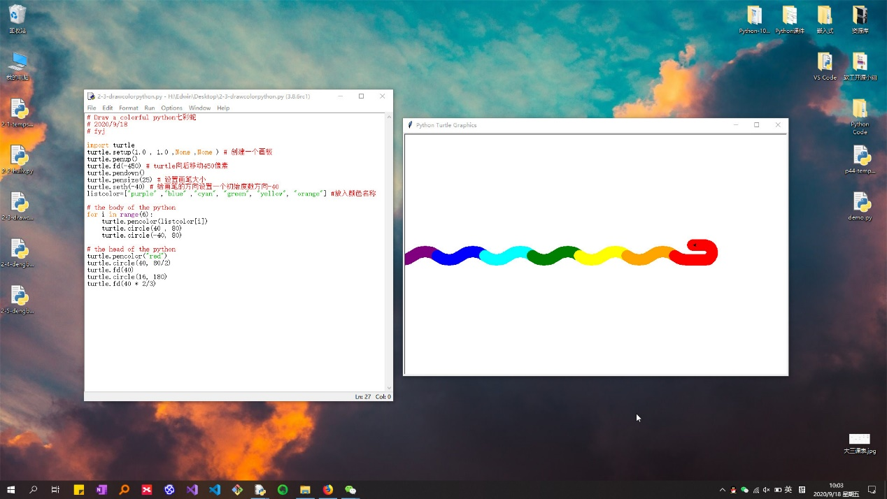

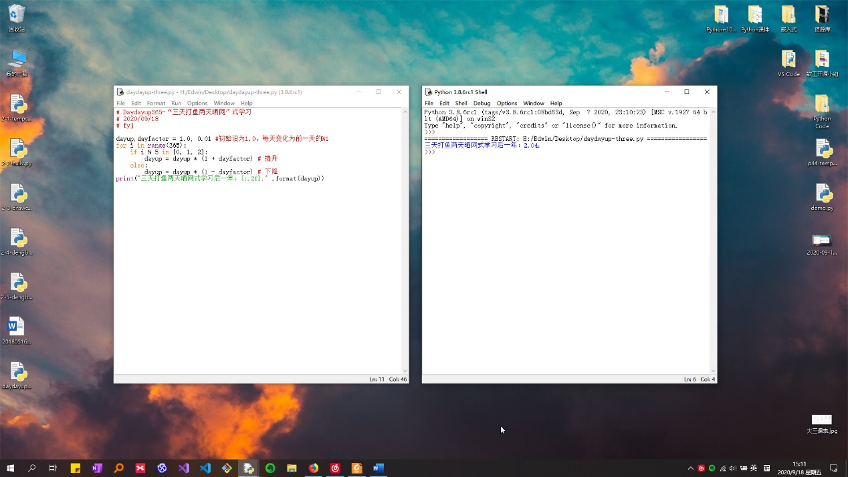

1. **代码：**

# Draw a colorful python七彩蛇

# 2020/9/18

# fyj

import turtle

turtle.setup(1.0 , 1.0 ,None ,None ) # 创建一个画板

turtle.penup()

turtle.fd(-450) # turtle向后移动450像素

turtle.pendown()

turtle.pensize(25) # 设置画笔大小

turtle.seth(-40) # 给画笔的方向设置一个初始度数方向-40

listcolor=["purple" ,"blue" ,"cyan", "green", "yellow", "orange"] #放入颜色名称

# the body of the python

for i in range(6):

turtle.pencolor(listcolor[i])

turtle.circle(40 , 80)

turtle.circle(-40, 80)

# the head of the python

turtle.pencolor("red")

turtle.circle(40, 80/2)

turtle.fd(40)

turtle.circle(16, 180)

turtle.fd(40 * 2/3)

1. **代码**

# Daydayup365-“三天打鱼两天晒网”式学习

# 2020/09/18

# fyj

dayup,dayfactor = 1.0, 0.01 #初始设为1.0，每天变化为前一天的%1

for i in range(365):

if i % 5 in [0, 1, 2]:

dayup = dayup * (1 + dayfactor) # 提升

else:

dayup = dayup * (1 - dayfactor) # 下降

print("三天打鱼两天晒网式学习后一年：{:.2f}." .format(dayup))